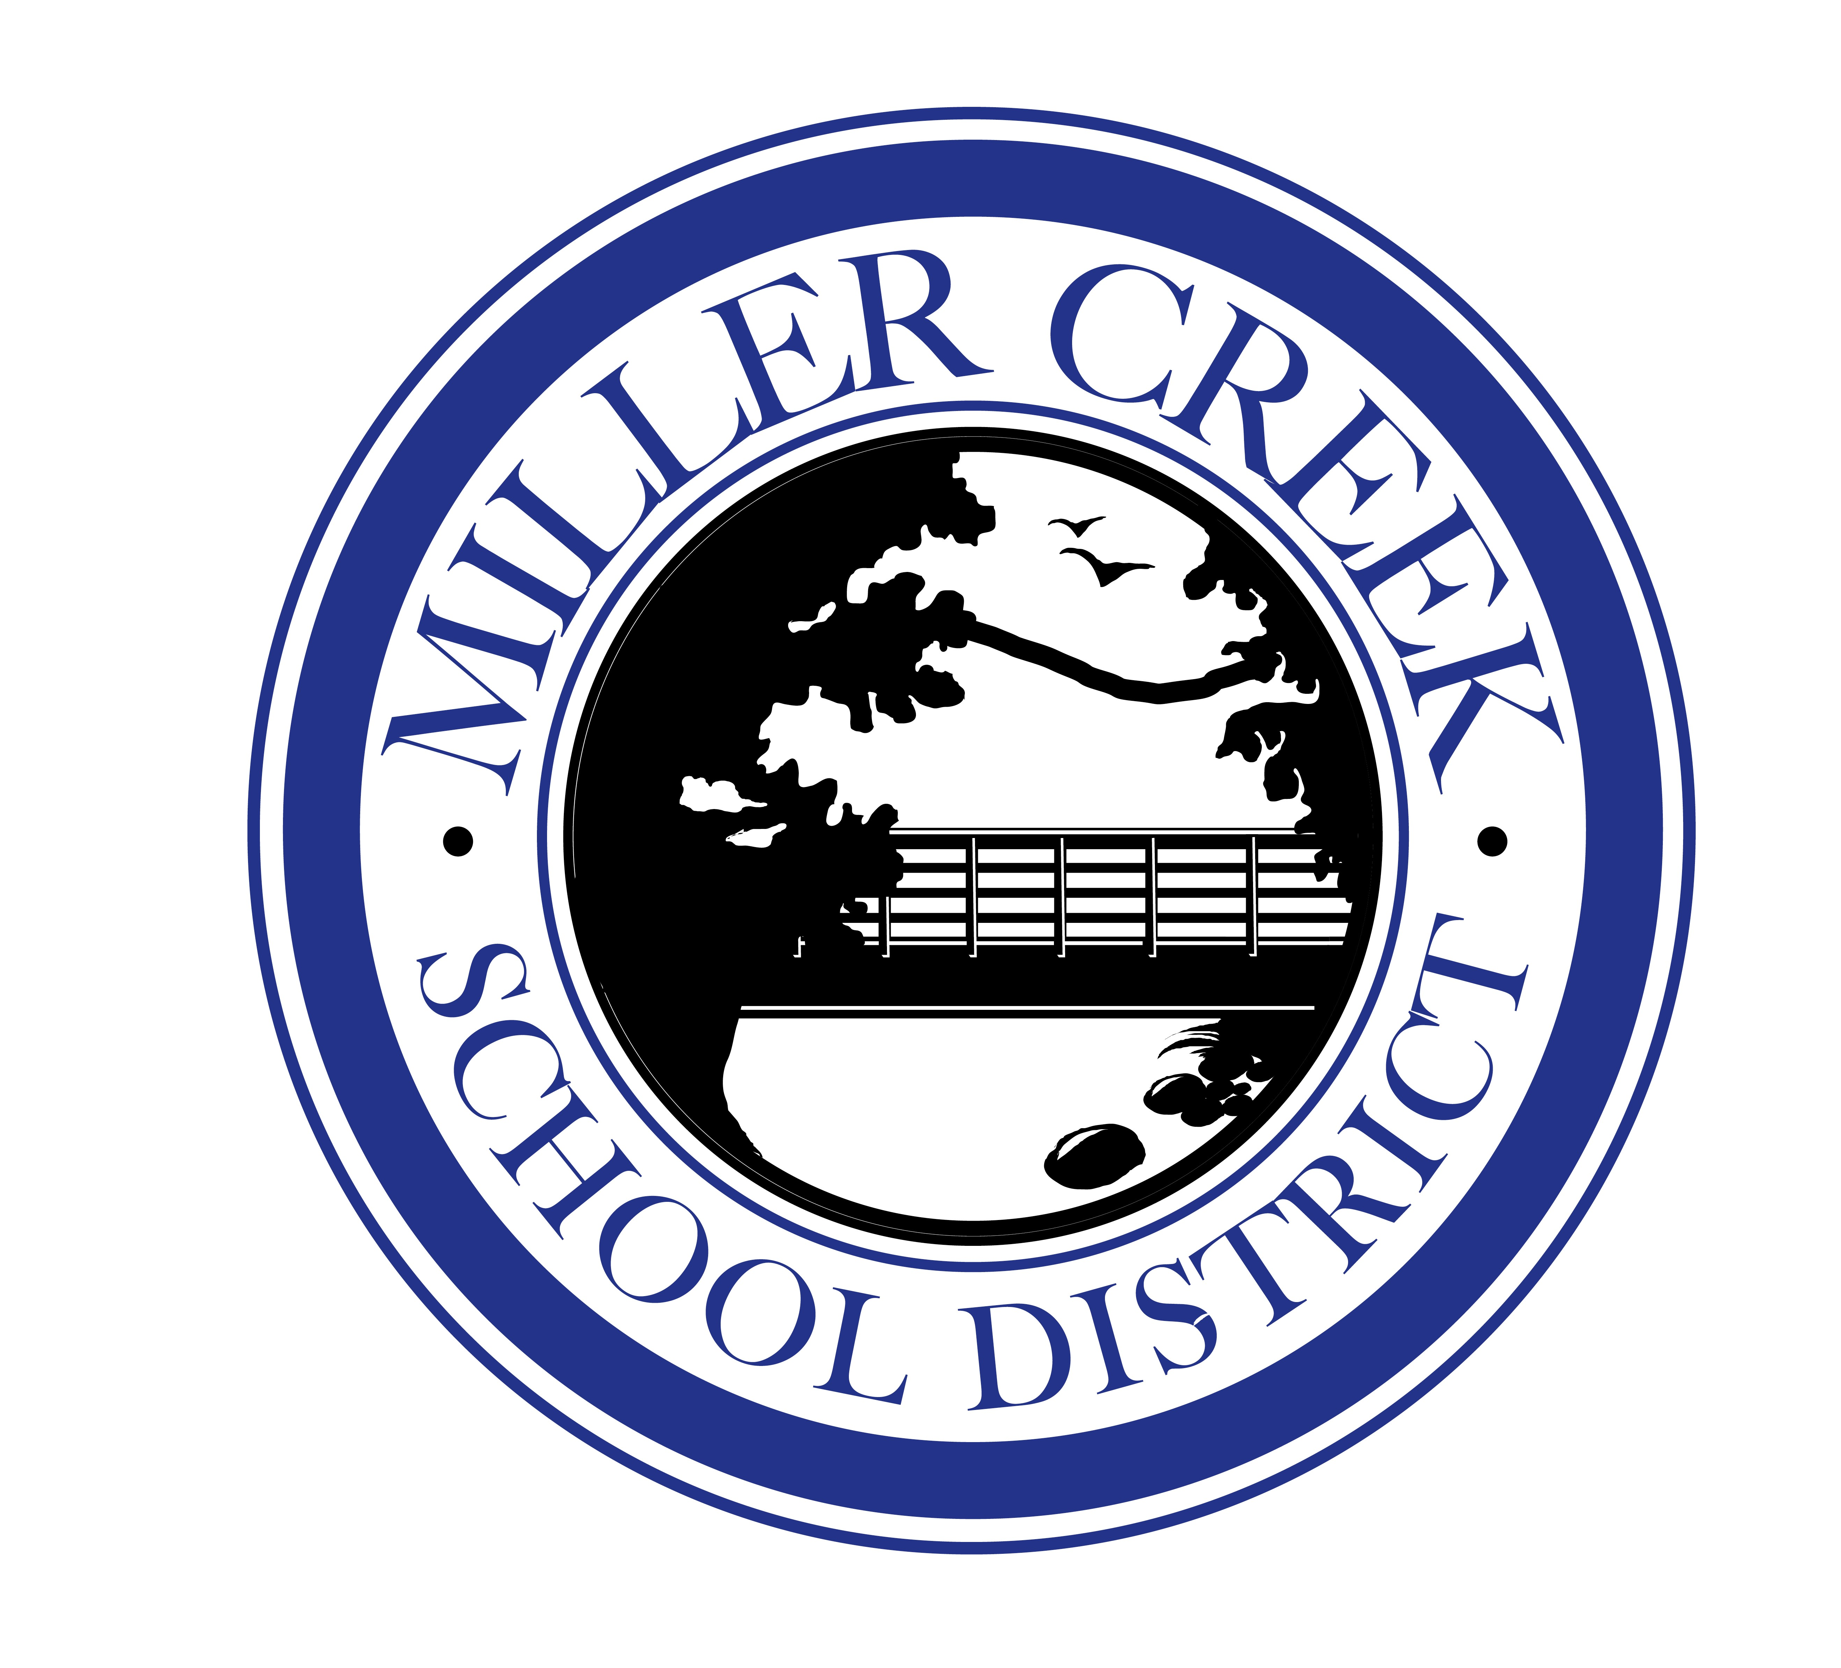
MILLER CREEK SCHOOL DISTRICT
CITIZENS’ BOND OVERSIGHT COMMITTEE

Meeting Agenda

Thursday, December 5, 2019
4:00-5:00pm
Miller Creek School District Board Room

Committee Members:
Patti Bender, Therese Bruton, Ruth Carter, Larry Cunha, Andy Falk and Ryan Madden

Purpose | Duties
The purposes of the Committee are set forth in Prop 39. They committee shall:  - Inform the Public concerning the District’s expenditures of bond proceeds.  - The Committee may review quarterly expenditure reports produced by the district.  - The Committee shall present to the Board an annual written report | Duties of the Committee will include:  - Ensure Bond funds are spent only on projects listed in the Bond Project List and no funds are used for salaries or general operating expenses.  - Monitor progress of Bond projects.  - Receive and review copies of the annual performance and financial audits of Bond projects as required by California State law (Proposition 39).  - Provide information to the public on the progress of Bond projects and expenditures of Bond funds.

Meeting Opening

4:00 Welcome, Introductions, and Review of Agenda B. Rosales

Presentation and Discussion Items:

4:10 Review/Approve Minutes Committee

4:20 Bond Project Update Todd Lee
Greystone

Jamie Ferranti
Greystone
4:40 Financial Report Tanya Michel

4:55 Select March 2020 Date Committee

5:00 Adjourn

